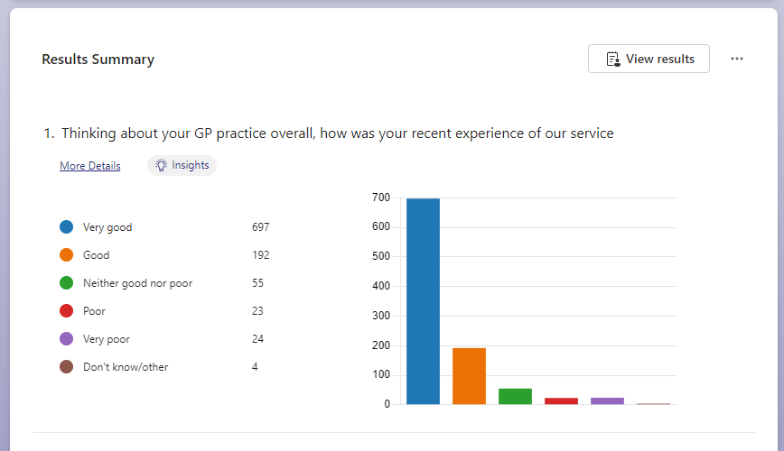

FRIENDS & FAMILY TEST RESULTS JUNE - DECEMBER 2023

