GP registration supplementary questionnaire
Please complete in BLOCK CAPITALS and tick as appropriate OR mark as N/A if not applicable
CORRESPONDENCE ADDRESS
If you live in one of the local caravan/leisure sites where there is no postal service, or you are of ‘no fixed abode, or in temporary accommodation, please provide us with an address for sending letters to
POST CODE:
If you are from abroad but were previously registered in the NHS please give the date you left the UK
EX-MILITARY SERVICE/VETERAN please indicate your service |  |  |  |  |  |  |  | Air Force Army Marines Navy Reservist
Please give the address you were last registered with a GP before enlisting

POST CODE:
Enlistment date: |  |  | Discharge date: |  |  |  |  |  |  | Service/Personnel No.
Are you a family member (partner or child) of an active HM Forces person? |  |  |  |  |  |  |  |  |  |  |  | YES NO
Is your EMERGENCY CONTACT registered at our Practice?  Is your NEXT OF KIN registered at our Practice? |  |  |  |  |  |  | YES NO  YES NO
GENDER IDENTITY | Female Male Intersex MtF Female FtM Male He She They
GENDER ID/ASSIGNMENT To ensure you receive important health screening, please tell us if you retain any of the following:-

female reproductive organs No Yes |  |  |  |  | male reproductive organs No Yes |  |  |  |  |  |  |  | Breast tissue No Yes
FEMALE Only Are you currently pregnant or think you may be? |  |  |  |  |  |  |  |  | No Yes* Expected due date:
* Please visit www.porthosp.nhs.uk/departments/maternity/pregnant.htm and complete the maternity self-referral form
Status  please tick all that apply |  | Married Single Widowed Cohabiting Refugee Asylum seeker Homeless  Housebound Retired Registered blind Registered deaf Registered disabled
Do you use a service/support animal eg: guide dog? |  |  |  |  |  | No Yes please give brief details
CARER DETAILS
If you have a carer please provide their name/contact details? |  |  | Name* or Agency:  Contact No.  * Only add personal name details if they consent to have them stored in your medical record
Are they registered at our Practice |  |  |  | No Yes
If you are an unpaid/informal carer, we want to make sure you are fully supported in your caring role. You may wish to complete our referral form or visit www.portsmouth.gov.uk/services/health-and-care/carers/portsmouth-carers-centre/
A carer is a person who looks after a relative, friend or neighbour who needs support because of their age, a physical or learning disability, a physical or mental illness, substance misuse problem or limiting illness

Who do you look after? | Name |  |  | DOB
What is their relationship to you? |  | Spouse/partner Relative Friend Neighbour
Do they live with you? | YES NO | Are they registered with us? |  | YES NO
Do they consent to their details in your medical record? |  |  | YES NO
Would you like us to refer you to Portsmouth Carers Centre? |  |  | Yes please No thank you
YOUR ADDITIONAL MEDICAL HISTORY
Are you currently under the care of any support network, healthcare agency or any other service responsible for your health, care and welfare? (eg: Children or Adult Social Services, Learning Disability organisation etc)
No Yes please give brief details

Do you have any current or had any past significant condition(s), operation(s) or hospital admission(s)?
No Yes please give brief details

If you are currently under the care of a Hospital, Health service or Consultant outside our area, please tell us who:
YOUR VACCINATION HISTORY (adult)
I am less than 24 years old and have had two doses of the MMR Vaccination |  |  |  | Yes No Unsure
I am less than 25 years old and have had a Meningitis C Vaccination |  |  |  | Yes No Unsure
ELECTRONIC PRESCRIBING All prescriptions are now sent electronically direct to a pharmacy
Please confirm the details of the pharmacy you would like your prescriptions sent to (includes ALL prescriptions eg: antibiotic treatment). If you are not sure which pharmacy you wish to use, we will allocate the closest to you. |  |  | Pharmacy name:  Location/Road name:
NHS BLOOD DONOR REGISTRATION All blood types are needed, especially O negative and B negative. You can give blood if you are: • Fit & healthy • Weigh >50kg (7 st 12 lbs) • Age 17-66 (or 70 if already a donor) • Age >70 & given blood in the last 2 years
Blood Donation | I am already a blood donor (Tick here if you have given blood in the last 3 years )  I wish to be a blood donor please visit www.blood.co.uk/the-donation-process/recognising-donors or call 0300 123 23 23 to speak to an advisor who will send you a donor card  I do not wish to be a blood donor
NHS ORGAN DONOR REGISTRATION England has moved to an 'opt out' system, referred to as 'Max and Keira's Law'. This means all adults in England are considered to have agreed to be an organ donor when they die unless they have recorded a decision not to donate. Your family will still be approached and your faith, beliefs and culture will continue to be respected. You still have a choice about whether you wish to become a donor
I do not wish to be an organ donor please visit: www.organdonation.nhs.uk or call 0300 123 23 23 to register your decision.
PATIENT PARTICIPATION GROUP We are committed to improving the services we provide. The Patient Participation Group is a mechanism for us to gain valuable feedback from our patients about their experiences, views and ideas for improving our services. For further information, please read the attached PPG information page
Would you like to be involved in our Patient Participation Group? |  |  | Yes No
ONLINE ACCESS TO YOUR HEALTH RECORD before completing, please read Access to GP Online Services (attached)
Please confirm your email address (please write clearly, as numbers, letters and symbols are often misread)

*** TO REGISTER FOR ONLINE ACCESS, WE REQUIRE PHOTOGRAPHIC PROOF OF YOUR IDENTIFICATION ***

I wish to have online access to my medical record |  | Yes No
and I understand & agree with each statement below:
1. I have read and understood the ‘Important Information’ section below

2. I will be responsible for the security of the information I see or download

3. If I choose to share my information with anyone, this is at my own risk

4. I will contact the practice as soon as possible if I suspect my account has been accessed without my agreement

5. If I see information in my record that is not about me, or is inaccurate I will log out immediately and contact the practice as soon as possible

PATIENT AUTHORITY/CONSENT TO SHARE INFORMATION WITH NOMINATED 3RD PARTY
Consent to Share Confidential Information with a Third Party

The Data Protection Act 2018 and the ethical codes of conduct of all health care professionals require that medical data be treated with great respect for confidentiality. We are not permitted to share any medical details with a third party without your consent

I do NOT give consent to share my medical information with any third party

I give consent to share my medical information with:
Full Name………………………………………………………………………………………………………………….. DOB …………………………………………………
Relationship to patient …………………………………………………………………………..…………. Tel No………………………………………………..

What type of information can be shared:

Test Results Yes No

Appointment Information Yes No

Medications Yes No

Current health Yes No

Other: (please state)……………………………………………………………

Please tell us if this consent is permanent or for a limited period from……………………..….….….to…………………….………..

Patient Signature …………………………….………………………………………………………………………...

Please note: - It is your responsibility to inform us if you change your mind and wish to remove your consent to share your medical information with the above-named person(s).

Prescriptions

With effect from 01 January 2008, any patient wishing for a person to collect a prescription on the patient’s behalf will have to give the Practice signed consent. Reception Staff will not be able to hand a prescription over to a third party without prior consent from the patient.

I do NOT give consent for any third party to collect prescriptions on my behalf.

I give consent for the person named below to collect prescriptions on my behalf

Full Name….……………………………………………………………………………………………………………….. DOB …………………………………………………

Relationship to patient …………………………………………………………………………..…………. Tel No………………………………………………………..
I understand this consent is to remain in force until notice of cancellation by me.

Please note we are unable to hand prescriptions to any third-party person under the age of 15

Leaving messages

In accordance with the Data Protection Act the Practice needs consent from a patient who has an answerphone and is happy to have a message left. Without consent, we are unable to leave messages

*it is important you keep us up to date with any changes to your contact details

I give consent to the Practice to leave messages on the answerphone of the telephone number they have on record for me*

I DO NOT give consent for the Practice to leave messages on my answerphone

By providing us with your mobile and email address, we will assume your implied consent to be contacted by either of these methods. We will only contact you with appointment details, test results, your health affairs, health campaigns or occasionally Patient Participation Group details

I consent to being contacted by SMS or email* I do NOT consent to being contacted by SMS or email

*it is important you keep us up to date with any changes to your contact details

GOOD BEHAVIOUR GUIDANCE AGREEMENT please read our ‘Zero Tolerance statement’
At Lighthouse Group Practice we are committed to ensuring everyone is treated with respect and dignity including all patients, their families, carers and our Practice team. To be registered with our Practice we are providing this guide to set out the type of conduct that is expected of ALL patients. All patients are expected to behave in the following manner:

- To be polite and respectful towards all individuals (Staff and other patients)
- To refrain from adopting a demanding, intimidating or hostile manner
- To be mindful of making unreasonable demands and unrealistic expectations
- Not to make inappropriate or unacceptable remarks to staff or other patients at the practice, including abusive remarks related to an individual’s age - sex - disability - gender reassignment - marriage/civil partnership - pregnancy - race - religion/belief - sexual orientation

- Not to undertake any form of threatening abuse or violence towards any individual (staff and other patients) at the practice.
- To respect surgery premises and property.

- To attend the surgery premises for the purpose of engaging with our services.

- To use our services responsibly including:
  - booking routine appointments in accordance with the practice’s policy
  - requesting urgent appointments only for genuinely urgent conditions
  - engaging with any signposting or advice for an alternative health service/agency, where appropriate
  - engaging with any remote appointments we may offer over the telephone (or video)
  - attending face-to-face services when it is important to be seen in person, (including when physically able to do so, rather than requesting a home visit)
  - attending all appointments on time or cancelling any booked appointments that are no longer required
  - requesting repeat prescriptions in good time, ensuring all items are ordered together rather than individual lots
  - using our health care professionals’ time appropriately e.g. do not seek appointments for minor ailments that can be self-treated in the first instance, avoid discussing multiple problems: 1 appointment = 1 problem, to not seek advice for yourself when accompanying another patient at their appointment
  - raising only genuine concerns or complaints you may have about your care or the services we provide you.

In return, as a patient you can expect:

- to continue to access all our services

- to be treated with respect, dignity and confidentiality

- to raise any concerns or complaints about your care or our services and that these will be investigated and responded to.

We would remind that all patients are free to register with a practice of their choice, provided the practice has an open patient list for new registrations and the patient lives within the practice area.
Any patients who commit inappropriate or unacceptable behaviours towards a GP, Practice staff, other patients or the surgery premises or property risk being removed from the practice list within 8-days’ notice. Before issuing such a notice, we will normally provide a warning letter, which will be held on record for 12 months. Any threatening, abusive or violent incidents will not be tolerated and will be reported to the Police. Any such incident will result in your immediate removal from the practice list with your care transferred to a special allocation scheme which manages violent and aggressive patients.
We invite patients to agree to the terms of this guide as a commitment to our ongoing relationship.
DECLARATION
I confirm that the information I have provided is correct to the best of my knowledge. I agree to comply with the above conditions and wish to be registered at the practice. I understand that if I commit any inappropriate or unacceptable behaviours as illustrated by this guidance, I will be removed from the practice patient list.
Signature | Signed on behalf of patient
PRINT Name |  | Date

Your Checklist Have you… ?
Read and completed ALL sections & signed Provided photo ID e.g. Passport, Photo Driving License
Provided current address details e.g. Bank statement, Utility Bill or Council Tax from within the last 3 months
Provided repeat prescription list and given preferred pharmacy details
Completed the Patient Authority form and/or Carer’s referral form (if applicable)
Read ‘Access to GP online services’, ‘Zero Tolerance statement’, ‘Patient Participation Group’

Important Information – Please read before completing registration form

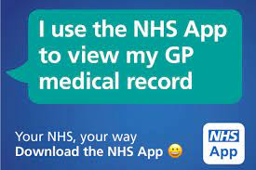

ACCESS TO GP ONLINE SERVICES

If you wish to, you can now use the internet (via computer or mobile app) to book appointments with a GP, request repeat prescriptions for any medications you take regularly and look at your medical record online. You can also still use the telephone or visit the surgery for any of these services as too. It’s your choice.

It will be your responsibility to keep your login details and password safe and secure. If you know or suspect that your record has been accessed by someone that you have not agreed should see it, then you should change your password immediately. If you are unable to do this for some reason, we recommend that you contact the practice so that they can remove online access until you are able to reset your password.

If you print out any information from your record, it is also your responsibility to keep this secure. If you are at all worried about keeping printed copies safe, we recommend that you do not make copies at all.

During the working day it is sometimes necessary for practice staff to input into your record, for example, to attach a document that has been received, or update your information; therefore, you will notice admin/reception staff names alongside some of your medical information – this is quite normal.

The definition of a full medical record is all the information that is held in a patient’s record; this includes letters, documents, and any free text which has been added by practice staff, usually the GP. The coded record is all the information that is in the record in coded form, such as diagnoses, signs and symptoms (such as coughing, headache etc.) but excludes letters, documents and free text.

Before you apply for online access to your record, there are some other things to consider. Although the chances of any of these things happening are very small, you will be asked that you have read and understood the following before you are given login details.

Forgotten history There may be something you have forgotten about in your record that you might find upsetting.
Abnormal results or bad news If your GP has given you access to test results or letters, you may see something that you find upsetting to you. This may occur before you have spoken to your doctor or while the surgery is closed and you cannot contact them.
Choosing to share your information with someone It’s up to you whether you share your information with others – perhaps family members or carers. It’s your choice but also your responsibility to keep the information safe and secure.
Coercion If you think you may be pressured into revealing details from your patient record to someone else against your will, it is best that you do not register for access at this time.
Misunderstood information Your medical record is designed to be used by clinical professionals to ensure that you receive the best possible care. Some of the information within your medical record may be highly technical, written by specialists and not easily understood. If you require further clarification, please contact the surgery for a clearer explanation.
Information about someone else If you spot something in the record that is not about you or notice any other errors, please log out of the system immediately and contact the practice as soon as possible.

For further information, please see: www.nhs.uk/NHSEngland/AboutNHSservices/doctors/Pages/gp-online-services.aspx

Please note that access to your FULL medical record will not be available until you have been FULLY registered

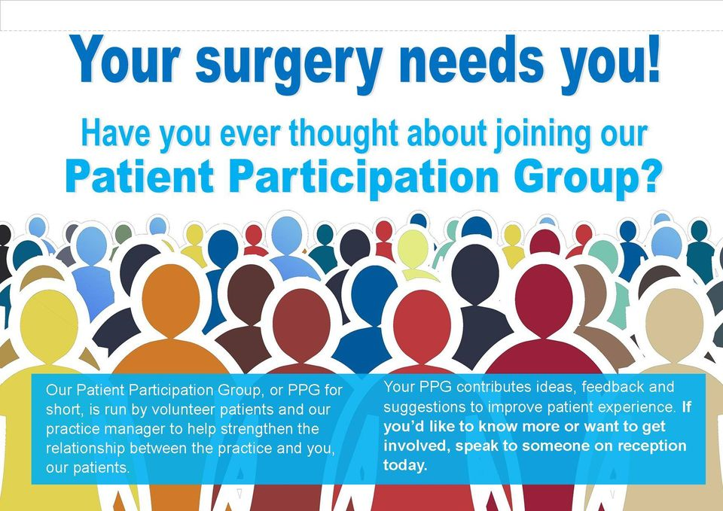

In practice, PPGs can play several roles, including:
- Advising the practice on the patient perspective
- Organising health promotion events
- Communicating with the wider patient body
- Running volunteer services and support groups to meet local needs
- Carrying out research into the views of those who use the practice (and their carers)
- Influencing the practice or the wider NHS to improve commissioning
- Fundraising to improve the services provided by the practice

From April 2016, it has been a contractual requirement for all English practices to form a patient participation group (PPG) during the year ahead and to make reasonable efforts for this to be representative of the practice population. The first Patient Participation Group was set up by a GP in 1972 and many general practices in England now have a PPG. Generally made up of a group of volunteer patients, the practice manager and one or more of the GPs from the practice, they meet to discuss the services on offer and how improvements can be made for the benefit of patients and the practice.
The beauty of PPGs is that there is no set way in which they work – the aims and work of each group depends entirely on local needs but they have the same aim of making sure that their practice puts the patient and improving health at the heart of everything it does.
Some groups have, for some years, looked beyond the surgery to the decisions made within the NHS that directly affect their community. Regrettably, most often it has been in reaction to decisions taken without adequate consultation. In many cases, patients and primary care professionals have supported each other in promoting the patient and public interest.

Benefits of a Patient Participation Group

PPGs are about implementing real, positive change in their communities. Patients have long valued the relationship with their GP and general practice.

However the dynamics of this relationship have changed over recent years – patients today rightly want more say in their own healthcare, they are better informed and expect to be treated as whole people, not just as a condition or ailment. PPGs have an increasingly important role to play in helping to give patients a say in the way services are delivered to best meet their needs and the needs of the local community.

PPGs can help GPs to develop an equal partnership with their patients. They can help them to communicate accurately and honestly with individual patients and with the wider community about key health matters. They can also help to reduce costs and improve services by identifying changes that the practice may not have considered, allowing resources to be used more efficiently. What is more, they can develop mutually supportive networks for patients and the practice, outside of individual appointments. For details, visit www.napp.org.uk/for-patients/

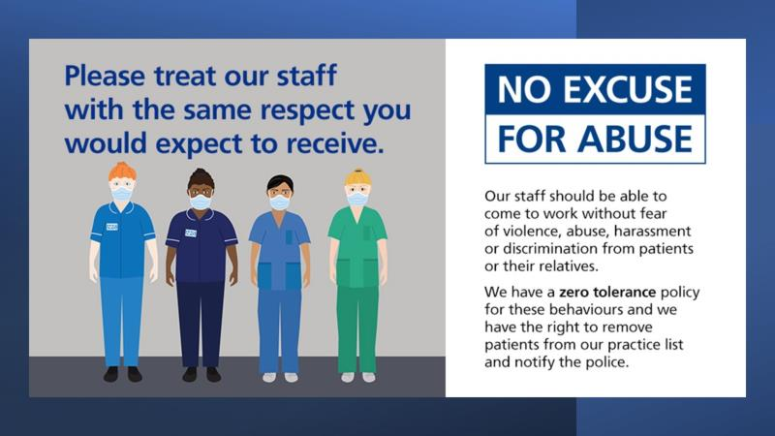
The Practice takes it very seriously if a member of our administrative staff, or one of our doctors, nurses or clinical team is treated in an abusive, hostile, aggressive or violent manner and supports the Government's 'Zero Tolerance' campaign for Health Service Staff, which states that GPs and their Staff ‘have a right to care for others without fear of being attacked or abused’. A mutual respect between all Staff and patients must be in place for us to successfully provide our services. Our staff aim to be polite, helpful, and sensitive to all patients’ individual needs and circumstances. We respectfully remind patients that Staff are often confronted with a multitude of varying and sometimes difficult tasks and situations; our Staff understand that unwell patients do not always act in a reasonable manner and will take this into consideration when dealing with a misunderstanding or complaint. However, aggressive behaviour, be it violent or abusive, will not be tolerated; the Police will be contacted, if necessary and the likely outcome would be your immediate removal, or an 8-day notice of removal, from the Practice list, which depending may include other family members.
For the practice to maintain good relations with their patients we request all patients to read and note the types of behaviour that is unacceptable:
- Using bad language or swearing at practice staff
- Intimidating, or threatening gestures and mannerisms
- Any physical violence towards any member of the Primary Health Care Team or other patients, such as pushing or shoving
- Verbal abuse towards the staff in any form including verbally insulting the staff
- Racial abuse and sexual harassment will not be tolerated within this practice
- Persistent demanding behaviours and/or unrealistic expectations that cause stress to staff will not be accepted. Requests will be met wherever possible and explanations given when they cannot
- Causing damage/stealing from the Practice's premises, Staff or patients
- Obtaining drugs and/or medical services fraudulently
We expect you to treat your GP and their Staff courteously. We provide a Good Behaviour Guidance Agreement for patients to consider and sign.

Removal from the practice list A good patient-doctor relationship, based on mutual respect and trust, is the cornerstone of good patient care. The removal of patients from our list is an exceptional and rare event and is a last resort in an impaired patient-practice relationship. When trust has irretrievably broken down, it is in the patient’s and Practice’s best interest that a patient should register at another practice. For acts of physical aggression, violence, damage to property and when the Police are involved, we will initiate immediate removal of the patient from our list.

Removing other members of the household This is particularly likely where the patient has been removed because of violence or threatening behaviour. In other circumstances it may be necessary to terminate responsibility for other members of the family or the entire household because visiting patients who reside with a removed patient, by virtue of their unacceptable behaviour, may put clinical Staff at risk; Staff being regularly confronted by the removed patient eg: parent or partner, may make it too difficult for the practice to continue to look after the whole family.

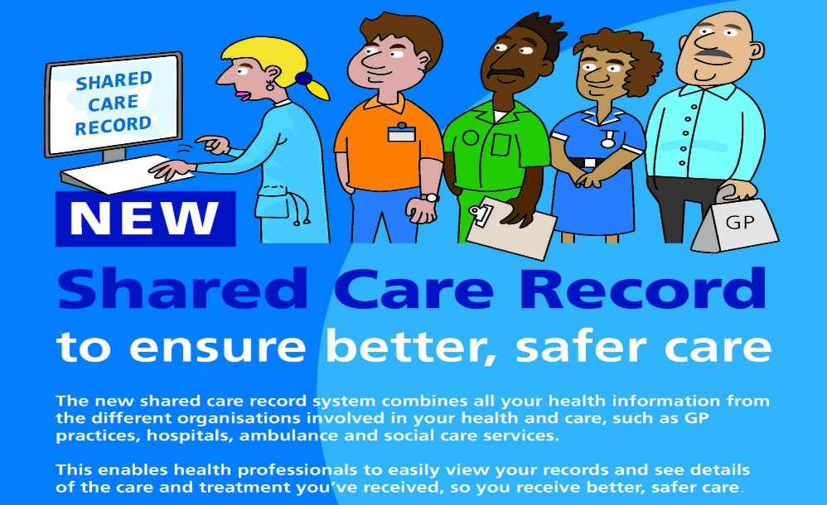
What is your health record? Your health record contains all the clinical information about the care you receive. When you need medical assistance it is essential that clinicians can securely access your health record. This allows them to have the necessary information about your medical background to help them identify the best way to help you. This information may include your medical history, medications and allergies.
Why is sharing important? Health records about you can be held in various places, including your GP practice and any hospital where you have had treatment. Sharing your health record will ensure you receive the best possible care and treatment wherever you are and whenever you need it. Choosing not to share your health record could have an impact on the future care and treatment you receive. Below are some examples of how sharing your health record can benefit you:
- Sharing your contact details ensures you receive any medical appointments without delay
- Sharing your medical history ensures emergency services accurately assess you if needed
- Sharing your medication list ensures you receive the most appropriate medication
- Sharing your allergies prevents you being given something to which you are allergic
- Sharing your test results prevents further unnecessary tests being required
Is my health record secure? Yes. There are safeguards in place to make sure only organisations you have authorised to view your records can do so. You can also request information regarding who has accessed your information from both within and outside of your surgery.
Can I decide who I share my health record with? Yes. You decide who has access to your health record. For your health record to be shared between organisations that provide care to you, your consent must be gained.
Can I change my mind? Yes. You can change your mind at any time about sharing your health record, please just let us know.
Can someone else consent on my behalf? If you do not have capacity to consent and have a Lasting Power of Attorney, they may consent on your behalf. If you do not have a Lasting Power of Attorney, then a decision in best interests can be made by those caring for you.
What about parental responsibility? If you have parental responsibility and your child is not able to make an informed decision for themselves, then you can decide about information sharing on behalf of your child. If your child is competent then this must be their decision.
What is your Summary Care Record? Your Summary Care Record contains basic information including your contact details, NHS number, medications and allergies. This can be viewed by GP practices, Hospitals and the Emergency Services. If you do not want a Summary Care Record, please ask your GP practice for the appropriate opt out form. With your consent, additional information can be added to create an Enhanced Summary Care Record. This could include your care plans which will help ensure that you receive the appropriate care in the future.
How is my personal information protected? The Lighthouse Group Practice will always protect your personal information. For further information, please see our Privacy Notice on our website or speak to a member of our team
What is National Data Sharing? Information about your health and care helps the NHS to improve your individual care, speed up diagnosis, plan your local services and research new treatments. NHS Digital has a legal responsibility to collect data and social care services. The NHS cannot analyse on its own, so we safely and securely share some with researchers, analysts and organisations who are experts in making sense of complex information. We only share what is necessary for each piece of research and wherever possible, identity information is removed. You can choose to stop your confidential patient information being used for purposes other than your own care and treatment. This choice is known as a national data opt-out, which will allow patients to opt out of their confidential information being used for research and planning.

Patients can view or change their national data opt-out at any time by using the online service www.nhs.uk/your-nhs-data-matters/ or by clicking on ‘Your Health’ in the NHS app and selecting ‘Choose if data from your health records is shared for research and planning’. For further information about your health records, please see: www.nhs.uk/NHSEngland/thenhs/records

